*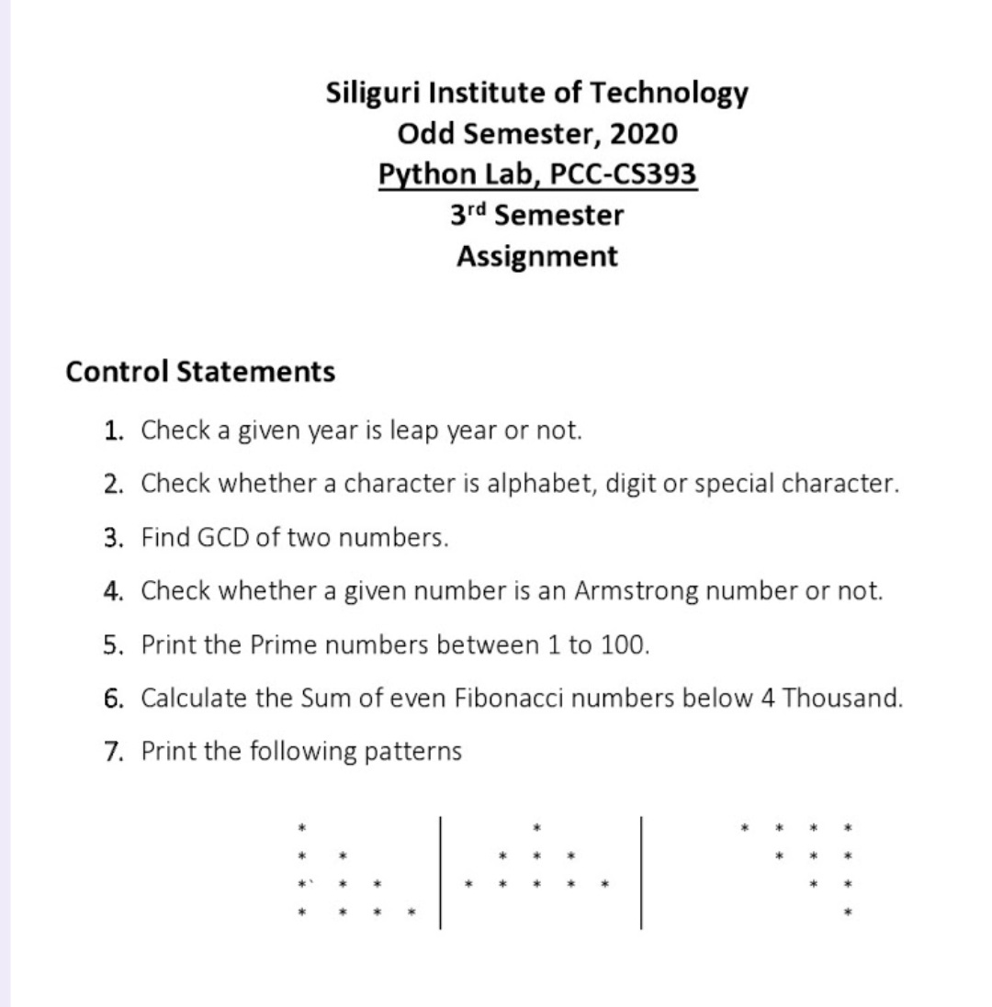****Exercise 1 –***

***Program –***

flag=1

while(flag==1):

year = int(input("Enter the year: "))

if((year%400 == 0) or ((year%4 == 0) and (year%100 != 0))):

print(str(year) + " is a leap year.")

else:

print(str(year) + " is not the leap year.")

intake=input("Do you wish to continue? (Press y to continue or any key to exit.): ")

if(intake=="Y" or intake=="y"):

flag=1

else:

flag=0

break

**

***Exercise 2 –***

***Program –***

flag=1

while(flag==1):

character = input("Enter the character: ")

if((character >= "A" or character >= "a") and (character <= "Z" or character <= "z")):

print("It's an alphabet.")

elif character.isdigit() is True:

print("It's an digit.")

else:

print("It's an special character.")

intake=input("Do you wish to continue? (Press y to continue or any key to exit.): ")

if(intake=="Y" or intake=="y"):

flag=1

else:

flag=0

break

*****Exercise 3 –***

***Program –***

flag=1

def gcd(a,b):

if(a>b):

num=a

deno=b

else:

num=b

deno=a

remainder = num%deno

while(remainder!=0):

num=deno

deno=remainder

remainder = num%deno

gcd=deno

return gcd

while(flag==1):

a=int(input("Enter your 1st number: "))

b=int(input("Enter your 2nd number: "))

print("Result: "+ str(gcd(a,b)))

intake=input("Do you wish to continue? (Press y to continue or any key to exit.): ")

if(intake=="Y" or intake=="y"):

flag=1

else:

flag=0

break

***Exercise 4 –***

***Program –***

flag=1

while(flag==1):

no = input("Enter the number: ")

length = len(no)

summ=0

temp = int(no)

while(temp!=0):

remainder=temp%10

summ+=pow(remainder,length)

temp=temp//10

if(summ==int(no)):

print(no + " is an armstrong number.")

else:

print(no + " is not an armstrong number.")

intake=input("Do you wish to continue? (Press y to continue or any key to exit.): ")

if(intake=="Y" or intake=="y"):

flag=1

else:

flag=0

break



***Exercise 5 –***

***Program –***

for num in range(2,100 + 1):

if (num > 1):

for i in range(2,num):

if (num % i) == 0:

break

else:

print(num, end=" ")

***Exercise 6 –***

***Program –***

def evenFibSum(limit) :

if (limit < 2) :

return 0

f1 = 0

f2 = 2

summ = f1+f2

while (f2 <= limit) :

f3 = 4*f2 + f1

if (f3 > limit) :

break

f1 = f2

f2 = f3

summ = summ + f2

return summ

print("The even fibonacci sum is " + str(evenFibSum(4000)) + ".")

**

***Exercise 7 –***

***Program –***

1. ***Pattern: 1***

flag=1

while(flag==1):

rows = int(input("No. of rows: "))

for i in range(1,rows):

for y in range(i):

print("*", end=" ")

print("")

intake=input("Do you wish to continue? (Press y to continue or any key to exit.): ")

if(intake=="Y" or intake=="y"):

flag=1

else:

flag=0

break

1. ***Pattern: 2***

flag=1

while(flag==1):

rows = int(input("No. of rows: "))

k=0

for i in range(1, rows+1):

for space in range(1, (rows-i)+1):

print(end=" ")

while k != (2*i-1):

print("* ", end="")

k = k + 1

k = 0

print()

intake=input("Do you wish to continue? (Press y to continue or any key to exit.): ")

if(intake=="Y" or intake=="y"):

flag=1

else:

flag=0

break

1. ***Pattern: 3***

flag=1

while(flag==1):

rows = int(input("No. of rows: "))

for i in range(0, rows):

for l in range(i):

print(' ', end='')

for k in range(i + 1, rows):

print('* ', end='')

print("")

intake=input("Do you wish to continue? (Press y to continue or any key to exit.): ")

if(intake=="Y" or intake=="y"):

flag=1

else:

flag=0

break